**NATIONAL UNIVERSITY FAIRVIEW**

**College of Engineering and Technology  
Bachelor of Science in Information Technology**

**with Specialization in Mobile and Internet Technology**

**Smart Fare: Automating modern public utility jeepney (MPUJ) Payment with an Innovative Fare Collection System**

Project Documentation Submitted to the Faculty of

Bachelor of Science in Information Technology

National University Fairview

In Partial Fulfillment of the Requirements for

PROJMAN – PROJECT MANAGEMENT

By

Team Leader:

Chua, Ronch Amos T.

Team Members:

Bacaling, Dominic T.

Baltazar, Crisha Maye O.

Balunsong, April Juliana A.

2023

Table of Contents

Scope Management Plan 3

6.2.1. Introduction 3

6.2.2. Scope Management Approach 3

6.2.3. Roles and Responsibilities 5

6.2.4. Scope Definition 10

6.2.5. Project Scope Statement 12

6.2.7. Scope Verification 15

6.2.8. Scope Control 15

### Scope Management Plan

### 6.2.1. Introduction

A Scope Management Plan is crucial for managing projects, especially in developing a Smart Fare Collection System (SFCS). SFCS is essential in urban transportation to transform fare-collecting procedures, improve user comfort, and increase operational efficiency. A well-defined Scope Management Plan ensures smooth implementation and promotes consensus among stakeholders. This strategy outlines the boundaries, goals, and outcomes of the SFCS project, providing a strategic guide for achieving project success. The plan emphasizes accuracy, flexibility, and ongoing stakeholder involvement to navigate the complexities of system development and deployment. Currently, it provides:

* An all-encompassing Scope Management Plan for the SFCS project.
* Emphasizing the importance of accuracy.
* Flexibility.
* Ongoing stakeholder involvement.

### 6.2.2. Scope Management Approach

The effective management of scope within a Scrum framework, particularly in the context of a Smart Fare Collection System (SFCS), necessitates incorporating flexibility, cooperation, and iterative planning.

Scope Planning Phase

The first stage of scope management for the Smart Fare project tries to identify stakeholders and the needs and determine the project's goals, specifications, and deliverables. The project’s goal is to develop a Smart Fare System that can monitor earning reports and implement cashless transactions for commuters. The scope statement will list the objectives, needs, and deliverables as well as stakeholders like Smart Fare management, operators, and end users. It will act as a manual for managing and carrying out projects.

Scope Verification and Validation

It is a vital aspect of the scope management process that involves validating the project's scope with stakeholders, including Smart Fare management, operators, and end-users. The primary goal is to ensure that the project's scope meets stakeholders' requirements and expectations. Stakeholders' feedback is collected through meetings, reviews, and presentations to verify that the project's scope aligns with the needs. The verification process ensures that the project's scope is complete, accurate, and current and keeping the project on track. By verifying the project's scope with stakeholders, the project team gains a clear understanding of the objectives and can move forward with confidence.

Scope Closing

It is the last step in the Smart Fare project’s scope management, which involves reviewing and accepting all deliverables to meet the project’s requirements. This step ensures that the project's objectives have been achieved and that all requirements have been met. Deliverables undergo a final review to verify the quality standards, while unfinished work is documented, and a formal closure is carried out to ensure Smart Fare satisfaction. Lessons learned are documented, project documentation is archived, and resources are released. The team can move on to new projects and can use the lessons learned to enhance future project management processes.

### 6.2.3. Roles and Responsibilities

Table Scope Management Roles and Responsibility

|  |  |  |
| --- | --- | --- |
| **Name** | **Roles** | **Responsibilities** |
| Mr. Mark Anthony Quiñon | Key Stakeholder/ Project Sponsor | * Determine whether to accept or reject requests for changes to the project's scope. * Determine whether there is a need for scope change requests |
| Mr. Christopher T. Carpio | Quality Assurance | * Conducting thorough testing and validation of the system to identify any deviations or gaps in the scope. * Identifying and reporting any scope creep or changes that may impact the project's scope. * Ensuring that the project documentation, such as requirements specifications and design documents, accurately reflect the defined scope. |
| Mr. Christopher T. Carpio | Project Adviser | * Providing guidance and expertise in defining the project scope and objectives. * Providing recommendations on scope prioritization and potential trade-offs based on resource constraints and project constraints. * Offering insights and suggestions for managing risks and mitigating potential scope-related issues. |
| Chua, Ronch Amos | Project Manager | * Collaborating with key stakeholders and project sponsors to clearly define and validate the project scope, objectives, and deliverables. * Providing regular updates to key stakeholders / project sponsors on scope-related matters, such as changes, risks, and issues. This involves preparing and presenting reports, managing expectations, and seeking their input and approval when required. * Facilitating communication and coordination between stakeholders, project sponsors, and the project team to ensure alignment and shared understanding of the project scope. This includes conducting regular meetings and status updates. * Leading the project team in breaking down the project scope into manageable tasks and sub-tasks, assigning responsibilities, and monitoring their progress. This involves providing clear direction and guidance to the team. |
| Balunsong, April Juliana | Product Designer and Researcher | * Working closely with the project team to develop a clear and detailed design scope statement, outlining the specific design deliverables, requirements, and constraints. * Continuously monitoring and reviewing the design implementation to ensure it remains aligned with the project scope, objectives, and quality standards. This includes conducting periodic design inspections and providing feedback for improvements or adjustments as needed. * Ensuring that the design adheres to the defined scope by actively monitoring and controlling design activities, making sure that they stay within the established boundaries. |
| Baltazar, Crisha Maye | Product Engineer and Researcher | * Working closely with the project team to develop a clear and detailed engineering scope statement, outlining the specific engineering deliverables, requirements, and constraints. * Ensuring that the engineering work adheres to the defined scope by actively monitoring and controlling engineering activities, making sure they stay within the established boundaries. * Conducting regular engineering reviews and presenting technical concepts to key stakeholders and project sponsors to ensure that the engineering work aligns with the approved scope and meets their expectations. |
| Bacaling, Dominic | Programmer | * Developing software code and programming solutions that align with the approved scope and meet the project's objectives. * Conducting regular code reviews and testing to ensure that the developed software adheres to the defined scope and meets the quality standards. * Assisting in scope verification by providing input and technical expertise during the testing and validation of software functionalities against the approved scope. * Collaborating with the project team to manage any scope changes or updates by assessing the impact on the software development, providing insights and estimates for the required modifications. |

### 6.2.4. Scope Definition

This project's scope includes developing a system that will collect fare payment alongside its data for the Modern Public Utility Jeepneys of the NOVADECI. The system will consist of the following features:

* Implement Payment Kiosk Method: Implement a GCash and Paymaya electronic wallet for contactless and cardless payments. To integrate GCash and PayMaya as payment options for your smart fare project, you must register merchant accounts with both platforms, implement their APIs into your system, and handle server-side and client-side integration, including error handling and security. GCash utilizes DragonPay for its Philippine payment gateway.
* Monitor the daily income: The team will create a database to contain transaction information, logic to process payments, income calculations and updates based on finalized transactions, and a dashboard from which to view and produce reports.
* Monitor the daily and weekly number of passengers: Track successful transactions and record passenger information in a database. Implement logic to count and aggregate the number of passengers within daily and weekly intervals and give reporting capabilities or statistics to monitor and show the passenger counts.
* Display the rates of drop-off locations: Our team will maintain a database or configuration file containing rates for drop-off locations, fetch the relevant rates depending on the specified drop-off location, and display them on the mobile application interface. They will also ensure the rates are updated if any changes are made.

In terms of programming languages and software the team will use Microsoft Visual Studio as the main programming platform and the languages that will be utilize are:

* NFC (Near Field Communication) Payment Integration: Utilize Java or Kotlin for Android development to leverage the native NFC capabilities of Android devices, enabling secure payment transactions.
* Backend Development and Database Management: Firebase can be used for the backend development, implementing business logic, and income monitoring. Realtime Database, such as authentication, cloud functions, hosting, and analytics, making it a comprehensive platform for the development of the app.

The project will be considered complete upon successful deployment of the Payment system and the features that are expected to be implemented with the project.

6.2.4 Work Breakdown Structure

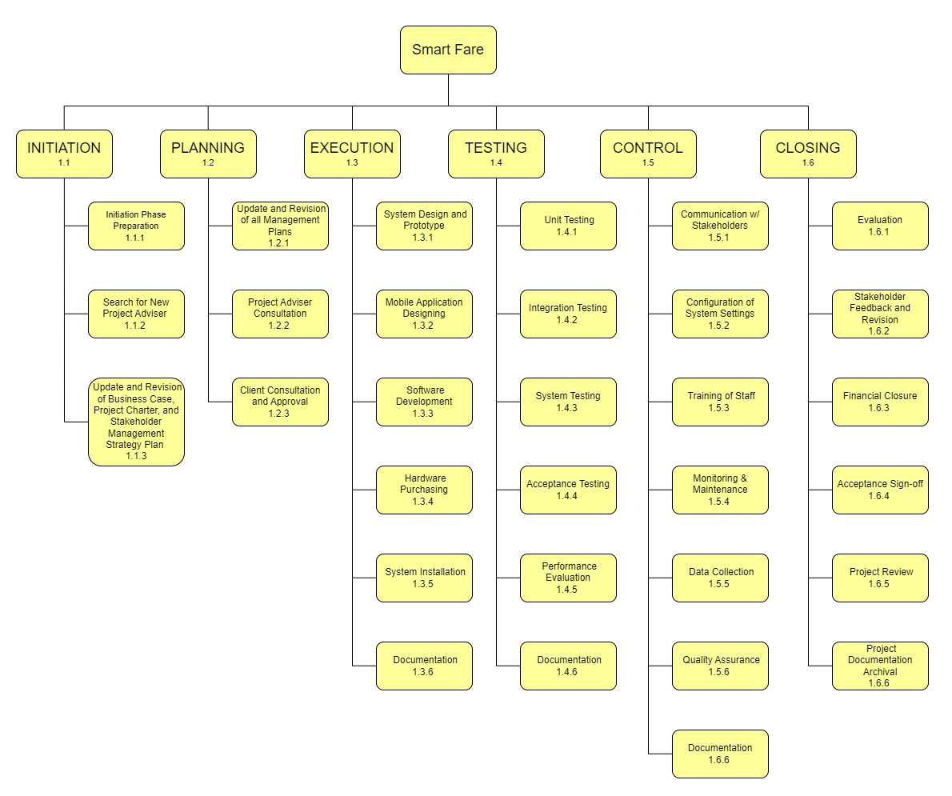

### 6.2.5. Project Scope Statement

Product Scope Description:

The project aims to develop a comprehensive fare payment system for NOVADECI's Modern Public Utility Jeepneys. The system will enable contactless and cardless payments through NFC technology by implementing GCash electronic wallets. Additionally, it will include features to monitor daily income, estimate passenger pick-up and drop-off times, track the daily and weekly number of passengers, and display drop-off location rates on a mobile application interface.

Product Acceptance Criteria:

To be accepted as complete, the project must meet the following criteria:

* Successful deployment of the fare payment system and all specified features.
* Integration of GCash as payment options with proper server-side and client-side integration, error handling, and security measures.
* Database implementation to store transaction information, enable payment processing, income calculations, and produce reports.
* Functioning dashboard to view and generate reports on daily income, passenger pick-up and drop-off locations, and passenger counts.

Project Deliverables:

* Fully functional fare payment system with NFC integration and support for GCash electronic wallets.
* Implemented database for transaction information storage, payment processing, income calculations, and reporting.
* Dashboard interface for viewing and producing reports on daily income, pick-up and drop-off locations, and passenger counts.

Project Exclusions:

* Hardware procurement of NFC-enabled devices.
* Network infrastructure setup for data transmission.
* Development of GCash APIs.
* Additional features and functionality beyond the specified scope.

Project Constraints:

* Time constraint: The project must be completed within the specified period.
* Budget constraint: Project costs must be managed within the allocated budget.
* Resource constraint: Outsourced junior and senior programmers will be involved in the project.

Project Assumptions:

* The NOVADECI Modern Public Utility Jeepneys will be equipped with the necessary hardware and infrastructure to support payment kiosk methods such as GCash.
* The project team can construct a powerful database that stores transaction information, processes payments, calculates revenue based on concluded transactions and generates a user-friendly dashboard for viewing and reporting.
* The project team will create a database to track passenger pick-up and drop-off times, process payments, compute revenue based on finished transactions, and offer a dashboard for monitoring and reporting.

The project team will implement logic and functionality to track successful transactions, record passenger information, count, and aggregate passengers daily and weekly, and provide reporting capabilities or statistics for monitoring and displaying passenger counts.

### 6.2.7. Scope Verification

The scope verification is the actual acceptance of project deliverable by the project sponsor. The project team aims to get the deliverables accepted by, first, letting the project sponsor and stakeholders read the project scope statement to know what areas will be included in this projects and what aspects will be excluded. Second, the project team will let the project sponsor and stakeholders assess the project plan and present the framework which comprises the proper structure of deliverables. Third, the project team will then make the actual system test and inspected to investigate any deviations needed. Once the system does not need any further alterations, the project is then open for project sponsor’s and stakeholder’s approval. With that, the system is set to be used on actual MPUJ.

### 6.2.8. Scope Control

The scope control oversees the changes within the project's scope. The scope control for the Smart Fare project will first entail the progress and direction of the project to evaluate if the objectives, deliverables, and project scope are met. Second, the project manager will review any suggested changes to see how it will enhance or harm the project in terms of the researchers’ project intent, scope, budget, schedule, and availability of resources and additional requirements. Given the situation if the project manager refuses to proceed with the changes, they will have to inform the team, project sponsor, and stakeholder why such request is denied. However, if the proposed changes are considered, the project manager will have to discuss with the rest of the team how the project’s direction will pivot. The project manager will contact the project sponsor and stakeholder to document the suggested changes, reach certain agreements, and further approvals. Consequently, the project manager and the rest of the team will produce solutions and strategies to combat any adverse impact on the project.